# Lab: Stream API

Problems for exercises and homework for the ["Java Advanced" course @ SoftUni](https://softuni.bg/courses/java-fundamentals).

You can check your solutions here: <https://judge.softuni.bg/Contests/Practice/Index/465#0>.

# Part I: Stream<T> and Types of Streams

## Take Two

Read a **sequence of integers**, given on a single line separated by a space.

Finds all **unique** elements, such that **10 ≤ n ≤ 20** and print only **the first 2 elements**.

If there are **fewer than 2 elements**, print as much as there are. If there are **no elements**, print nothing.

### Examples

|  |  |
| --- | --- |
| **Input** | **Output** |
| 15 2 15 14 12 | 15 14 |
| 17 -2 3 | 17 |
| -2 3 | (*no output)* |

### Hints

* Read the input using a Scanner or a BufferedReader and parse the strings to a list of numbers:

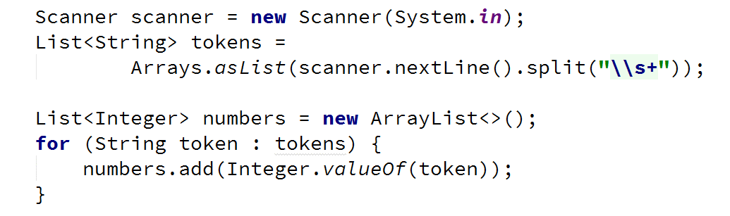

* Filter the numbers with filter(), take the unique ones with distinct(), take only two from the stream with limit() and iterate over them while printing with forEach():

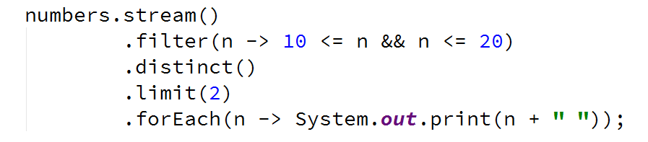

## Upper Strings

Read a sequence of strings, given on a single line separated with a space.

Map each to upper case and print them, using the Stream API.

### Examples

|  |  |
| --- | --- |
| **Input** | **Output** |
| Pesho Gosho Stefan | PESHO GOSHO STEFAN |
| Soft Uni Rocks | SOFT UNI ROCKS |
| *(empty line)* | *(no output)* |

### Hints

* Read the input using a Scanner or a BufferedReader into a list of strings List<String>:



* Call a stream over the list and map every element to upper case. Iterate over the stream and print the result:

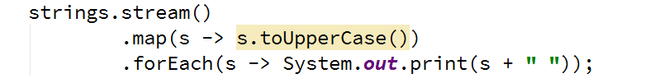

## First Name

Read a **sequence of names**, given on a single line, separated by a space.

Read a **sequence of letters**, given on the next line, separated by a space.

Find the **names that start with one of the given letters** and print the first of them (**ordered lexicographically**).

If there is **no name** that conforms to the requirement, **print "No match"**.

### Examples

|  |  |
| --- | --- |
| **Input** | **Output** |
| Rado Plamen Gosho  p r | Plamen |
| Plamen Gosho Rado  s c | No match |

### Hints

* You can use a hash set to store letter, for efficient searching
* Make sure you are comparing letter with the same casing (lower or upper)
* Use filter(), sorted() and findFirst()
* Use Optional<T>

## Average of Doubles

Read a **sequence of double numbers**, given on a single line, separated by a space.

Find the **average of all elements**, using the Stream API.

**Round** the output to the second digit after the decimal separator.

If there are **no numbers** in the sequence, **print "No match"**.

### Examples

|  |  |
| --- | --- |
| **Input** | **Output** |
| 3 4 5 6 | 4.50 |
| 3.14 5.2 6.18 | 4.84 |
| *(empty list)* | No match |

### Hints

* Use a primitive stream DoubleStream
* Use OptionalDouble
* Make sure to filter empty strings before transforming the stream

# Part II: Types of Operations

## Min Even Number

Read a sequence of numbers, given on a single line, separated by a space.

Find the smallest number of all even numbers, using the Stream API.

If there are **no numbers** in the sequence, **print "No match"**.

### Examples

|  |  |
| --- | --- |
| **Input** | **Output** |
| 1 2 3 4 5 6 | 2.00 |
| 3.14 -2.00 1.33 | -2.00 |
| *(empty list)* | No match |

### Hints

* Use map function to map the objects to Double
* Make sure to filter empty strings
* Filter the even numbers
* Get the smallest number using Double.compare(x1, x2)

## Find and Sum Integers

Read a sequence of elements, given on a single line, separated by a space.

Filter all elements that are integers and calculate their sum, using the Stream API.

If there are **no numbers** in the sequence, **print "No match"**.

### Examples

|  |  |
| --- | --- |
| **Input** | **Output** |
| Sum 3 and 4 | 7 |
| Sum -3 and -4 | -7 |
| Sum three and four | No match |

### Hints

* Use filter 🡪 map 🡪 reduce pattern
* Check if element's char at index 0 is a sign (+ or -)
* Check if all else element's chars are digits

## *Map Districts

On the first line, you are given the population count of districts in different cities, separated by a single space in the format "city:district population".

On the second line, you are given the minimum population for filtering of the towns. The **population of a town** is the **sum of populations of all of its districts**.

**Print** all **cities** with population greater than a given. **Sort** **cities** **and districts** by descending population and **print top 5 districts for a given city**.

For a better understanding, see the examples below.

### Examples

|  |  |
| --- | --- |
| **Input** | **Output** |
| Pld:9 Pld:13 Has:7 Sof:20 Sof:10 Sof:15  10 | Sof: 20 15 10  Pld: 13 9 |
| Sof:10 Sof:12 Sof:15  10 | Sof: 15 12 10 |
| Sof:5  15 | *(no output)* |

### Hints

* Read the input into a **proper collection**:

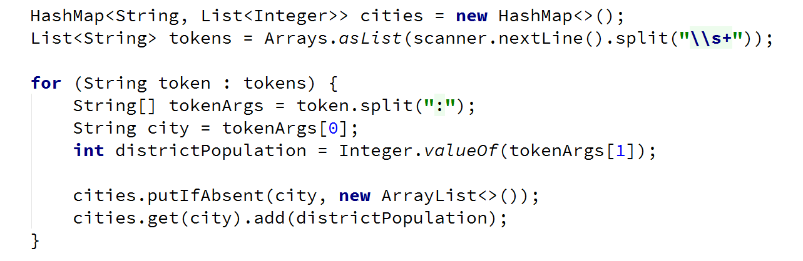

* Read the population bound



* **Filter**, **sort** and **print** the cities:

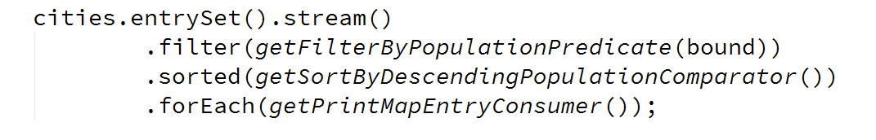

* Crete methods for generating **labda expressions**, stored in **functional interfaces**
* Crete a method that returns a **predicate for filtering**:

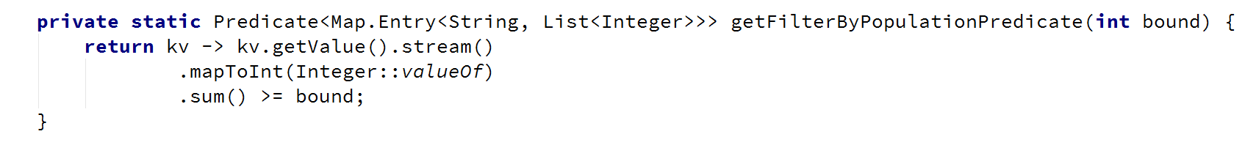

* Create a method that returns a **comparator for sorting:**

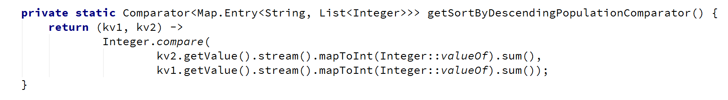

* Create a method that returns a **consumer for printing a map entry:**

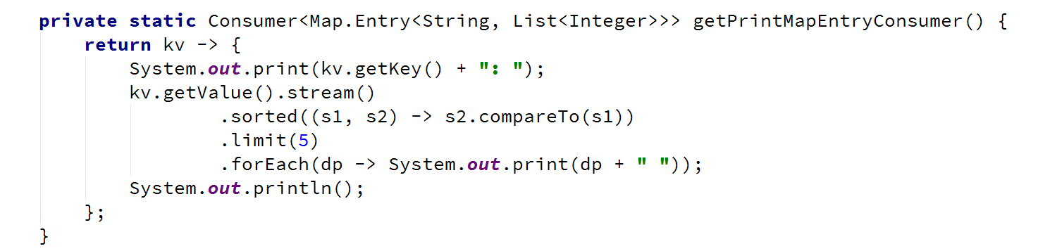

## Bounded Numbers

On the first line, read two numbers, a **lower** and **an upper bound**, separated by a space.

On the second line, read a sequence of numbers, separated by a space.

Print all numbers, such that [lower bound] ≤ n ≤ [upper bound].

### Examples

|  |  |
| --- | --- |
| **Input** | **Output** |
| 5 7  1 2 3 4 5 6 7 8 9 | 5 6 7 |
| 7 5  9 5 7 2 6 8 | 5 7 6 |
| 3 4  5 6 7 8 | *(no output)* |

### Hints

* Use collect(Collectors.toList())